**LAB REPORT - 2**

**Name**: Ajay Choudhury

**Roll no**.: 18018

**Experiment:** Filter Design

**Date of Submission**: 27-01-2021

**Solutions**

**Q. 1.**

|  |
| --- |
| % Here the values of phases are taken as zero fs = 1000; t = 0 : 1/fs : 1.5 - 1/fs; f1 = 10; f2 = 20; x = 3*cos(2*pi*f1*t) + 1*cos(2*pi*f2*t); xlim('auto') ylim('auto') plot(x) |

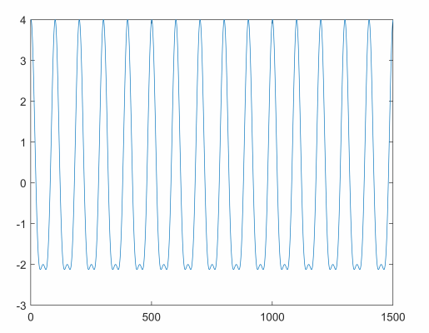

**Q. 1. b.**

|  |
| --- |
| % Fourier transform code: y = fft(x); length(x); X_mag = abs(y); plot(X_mag) xlabel('Frequency bins') ylabel('Amplitude') xlim('auto') grid on;  ylim('auto') |

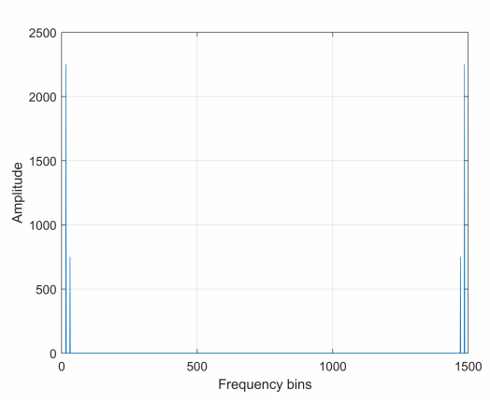

Interpretation: There are 2 frequencies present (let us consider the left half on the above graph for further inspection) and let us call the frequency on the right as F-low and the frequency on the left as F-high. Now, it can be seen from the above graph that the amplitude of F-low is 750Hz and the amplitue of F-high is 2250 Hz, which means that mathematically F-high = 3*F-low, which is true as the function s(t) which was used had 2 frequencies and the amplitude of one was 3 times the other (s = 3*cos(2*pi*f1*t) + 1*cos(2*pi*f2*t)). Therefore the phase values are reliable as well.

**Q. 1. c.**

|  |
| --- |
| X_phase = angle(y); % The bin Number of F-high is 16, it can be seen after zooming into the % above graph. X_phase(16) |

ans = 1.5940e-15

|  |
| --- |
| % The bin Number of F-low is 31, it can be seen after zooming into the % above graph. X_phase(31) |

ans = 3.0133e-15

The values of X_phase(16) and X_phase(31) are too low and close to zero.

**Q. 1. d.**

|  |
| --- |
| % let us assume values of phases this time. fs = 1000; t = 0 : 1/fs : 1.5 - 1/fs; f1 = 10; f2 = 20; x = 3*cos(2*pi*f1*t + 0.2) + 1*cos(2*pi*f2*t + 2.4); plot(x) xlabel('Samples') ylabel('Amplitude') xlim('auto') grid on; ylim('auto') |

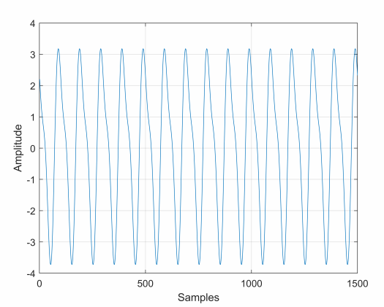

|  |
| --- |
| % Fourier transform code: y = fft(x); length(x); X_mag = abs(y); plot(X_mag) xlabel('frequency Bins') ylabel('Amplitude') xlim('auto') grid on; ylim('auto') |

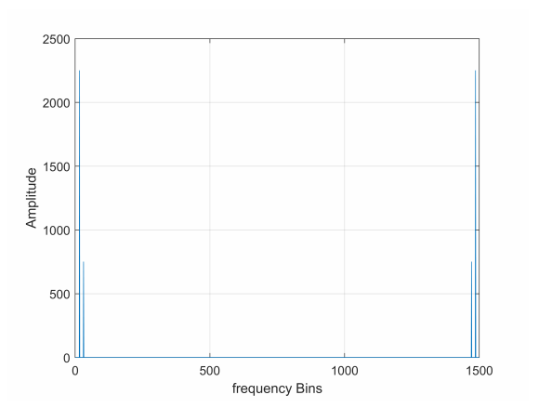

|  |
| --- |
| X_phase = angle(y); % The bin Number of F-high is 16, it can be seen after zooming into the % above graph. X_phase(16) |

ans = 0.2000

|  |
| --- |
| % The bin Number of F-low is 31, it can be seen after zooming into the % above graph. X_phase(31) |

ans = 2.4000

Now we can see the different value of phase.

**Q. 2. a.**

|  |
| --- |
| % we will now import 2 audio signals % importing audio sample file 1 whaleFile = 'bluewhale.au'; [~,fs] = audioread(whaleFile); t = 10*(0:1/fs:(length(whaleMoan)-1)/fs); plot(t,whaleMoan) xlabel('Time (seconds)') ylabel('Audio Signal') xlim([0 t(end)]) xlim([0.0 16.3]) grid on; ylim('auto') |

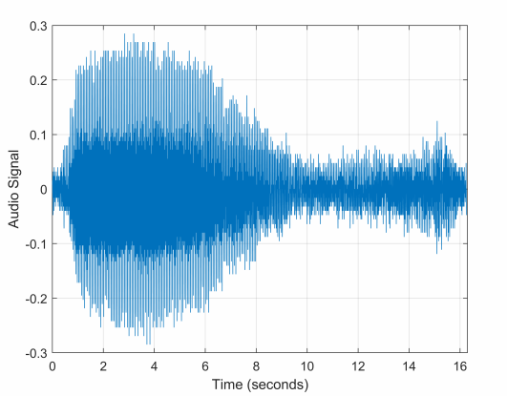

|  |
| --- |
| % importing audio sample file 2 handel = 'handel.wav'; [y,fs] = audioread(handel); t = 0:seconds(1/fs):seconds(info.Duration); t = t(1:end-1); plot(t,y) xlabel('Time') ylabel('Audio Signal') |

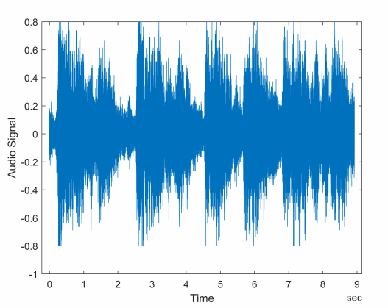

|  |
| --- |
| % importing audio sample file 3 [z,fs] = audioread('D:\ALL SEMESTERS\Semester VI\ECS 330 - Lab II\recording.wav'); |

**Q. 2. b.**

We will try to determine 5 prominent frequencies of both audio signals.

|  |
| --- |
| % For Audio sample file - 1  m = length(whaleMoan);  n = pow2(nextpow2(m));  y = fft(whaleMoan,n);  % frequency vector  f = (0:n-1)*(fs/n)/10;  % power spectrum  power = abs(y).^2/n;  plot(f(1:floor(n/2)),power(1:floor(n/2)))  xlabel('Frequency')  ylabel('Power') |

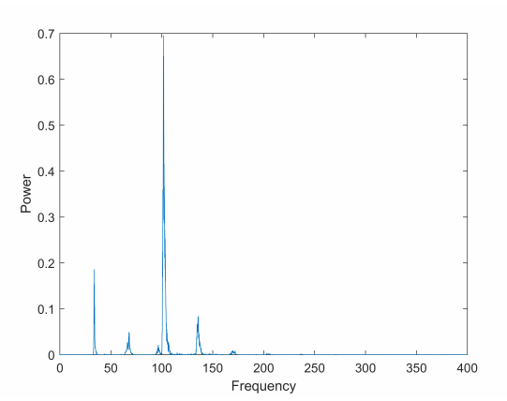

The 5 prominent frequencies of the above audio file are: 34.6Hz, 69.4Hz, 104Hz, 104.3Hz and 139Hz.

|  |
| --- |
| % For Audio sample file - 2  [y,fs] = audioread(handel);  N = length(y); % Length of vector y, number of samples  Y = fft(y,N); % Fourier transform of y  F = ((0:1/N:1-1/N)*fs); % Frequency vector magnitudeY = abs(Y); % Magnitude of the FFT  figure (1); plot(F, magnitudeY);  grid on;  xlabel('Frequency, Hz');  ylabel('Magnitude, dB'); xlim('auto')  ylim('auto');  title('Frequency spectrum'); |

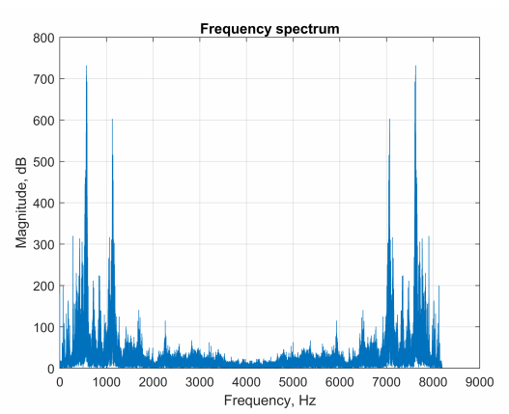

The 5 prominent frequencies of the above audio file are: 567Hz, 1124.5Hz, 7067.5Hz, 7625Hz and 7908Hz.

|  |
| --- |
| % For Audio sample file - 3  [y,fs] = audioread('D:\ALL SEMESTERS\Semester VI\ECS 330 - Lab II\recording.wav');  N = length(y); % Length of vector y, number of samples  Y = fft(y,N); % Fourier transform of y  F = ((0:1/N:1-1/N)*fs); % Frequency vector  magnitudeY = abs(Y); % Magnitude of the FFT  figure (1);  plot(F, magnitudeY);  grid on;  xlabel('Frequency, Hz');  ylabel('Magnitude, dB');  title('frequency spectrum');  xlim('auto')  ylim('auto') |

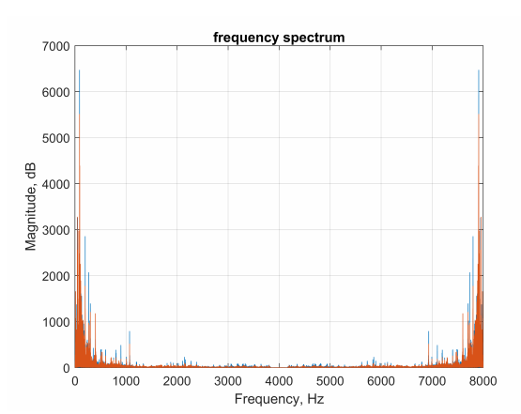

The 5 prominent frequencies of the above audio file are: 88.72Hz, 199.6Hz, 6931.4Hz, 7800Hz and 7911,2Hz.

**Q. 3. a.**

|  |
| --- |
| % signal plot:  fs = 1000;  t = 0 : 1/fs : 1.5 - 1/fs;  fm = 10; \ fc = 20;  mt = cos(2*pi*fm*t); % message signal  ct = cos(2*pi*fc*t); % carrier wave  plot(ct) xlabel('frequency Bins')  ylabel('Amplitude') |

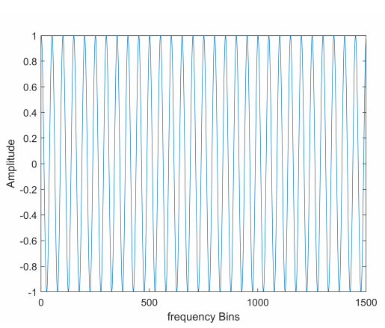

|  |
| --- |
| plot(mt)  xlabel('frequency Bins')  ylabel('Amplitude')  % Amplitude Modulation  fs = 100;  t = (0:1/fs:100)';  fc = 10;  x = sin(2*pi*t);  ydouble = ammod(x,fc,fs);  ysingle = ssbmod(x,fc,fs);  sa = dsp.SpectrumAnalyzer('SampleRate',fs,  ... 'PlotAsTwoSidedSpectrum',false,  ... 'YLimits',[-60 40]);  step(sa,ysingle) |

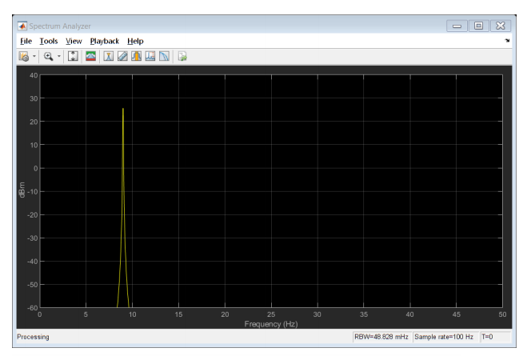

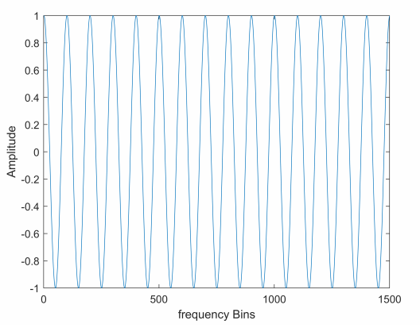

|  |
| --- |
| step(sa,ydouble) |

I am Unable to plot both Step double and single in a single report.

**Q. 3. b.**

|  |
| --- |
| % Magnitude spectrum  fm = 10;  fc = 20;  x1 = cos(2*pi*fm*t);  x2 = cos(2*pi*fc*t); x1(end) = [];  x2(end) = [];  %plot first half of DFT (normalised frequency)  Y_mags1 = abs(fft(x1));  num_bins1 = length(Y_mags1);  Y_mags2 = abs(fft(x2));  num_bins2 = length(Y_mags2);  plot((0:1/(num_bins1/2 -1):1), Y_mags1(1:num_bins1/2));  grid on;  title('Magnitude spectrum signal');  xlabel('Normalised frequency (\pi rads/sample)');  ylabel('Magnitude'); |

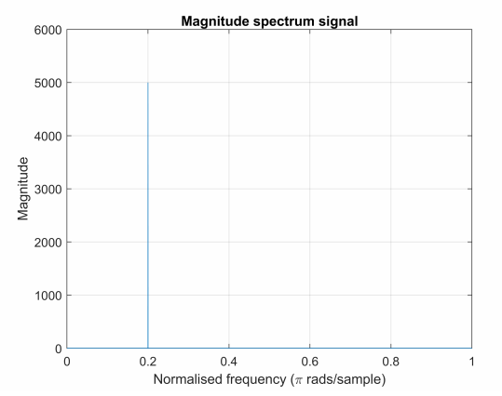

|  |
| --- |
| plot((0:1/(num_bins2/2 -1):1), Y_mags2(1:num_bins2/2)),  grid on;  title('Magnitude spectrum signal');  xlabel('Normalised frequency (\pi rads/sample)');  ylabel('Magnitude'); |

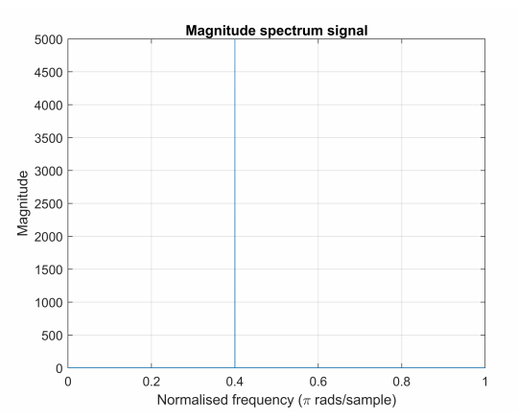

**Q. 3. c.**

|  |
| --- |
| % Time domain fm = 10;  fc = 20;  x1 = cos(2*pi*fm*t);  x2 = cos(2*pi*fc*t); tSampling=1/Fs;  n1=numel(x1);  t=-0.005:tSampling:-0.005+(n1-1)*tSampling;  plot(t,x1); |

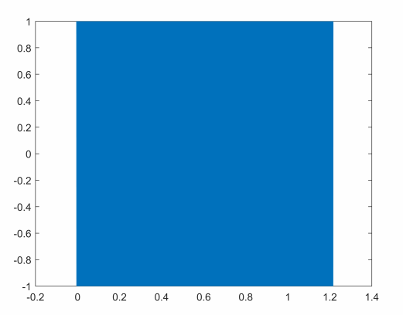

|  |
| --- |
| tSampling=1/Fs;  n2=numel(x2); t=-0.005:tSampling:-0.005+(n2-1)*tSampling;  plot(t,x2); |

